**Python Programming – String 2 of 10**

**Source: TCS CodeVita**

**Lexi String**

Little Jill jumbled up the order of the letters in our dictionary. Now, Jack uses this list to find the smallest lexicographical string that can be made out of this new order. Can you help him?  
You are given a string P that denotes the new order of letters in the English dictionary.  
You need to print the smallest lexicographic string made from the given string S.

**Constraints:**

1 <= T <= 1000  
Length (P) = 261 <= length (S) <= 100  
All characters in the string S, P are in lowercase  
  
**Input Format**  
The first line contains number of test cases T  
The second line has the string P  
The third line has the string S  
  
**Output**  
Print a single string in a new line for every test case giving the result  
  
**Test Case**  
Example 1  
**Input**  
2  
polikujmnhytgbvfredcxswqaz  
abcd  
qwryupcsfoghjkldezxvbintma  
ativedoc  
**Output**  
bdca  
codevita

**Explanation:**  
The transformed smallest lexicographical strings are in order they would be if order of letters are changed to string P

#Function to find the Lexi String

def GetLexiString(P,S):

#Initially the string is null

lexiStr=''

#For every character string P

for chars in P:

if chars in S:

#Add the chars as encountered

lexiStr+=chars

print(lexiStr)

#/*The main program*/

#Get the no of testcases

NoOfTCs=int(input())

#for each testcase get the input variables and call the function

for i in range(NoOfTCs):

P=input()

S=input()

GetLexiString(P,S)

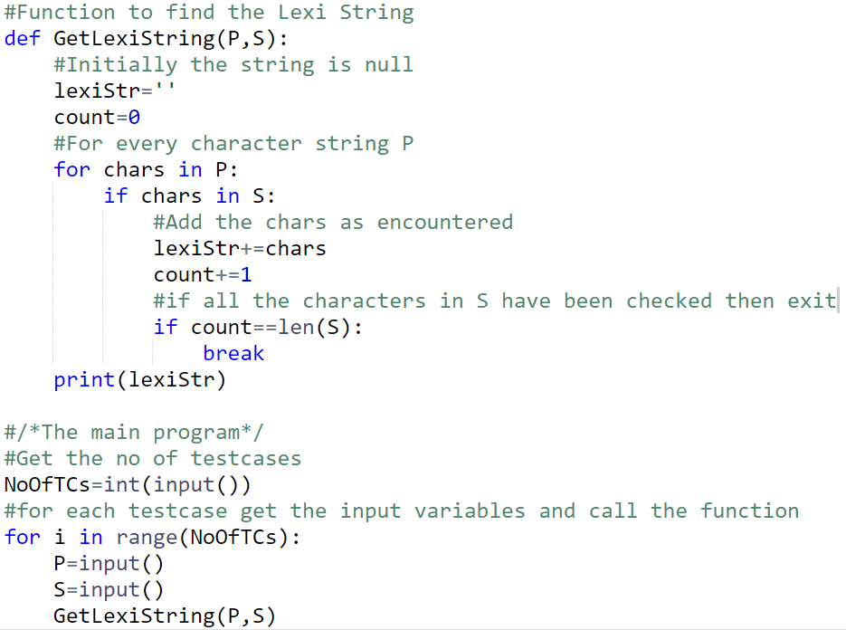

#Function to print LexiStrings

def LexiString(P,S):

LexiList=[chars for chars in P if chars in S]

print("".join(LexiList))

#/*Main Program*/

#Get the no of testcases

NoOfTC= int(input())

for i in range(NoOfTC):

P=input()

S=input()

LexiString(P,S)

#Function to print LexiStrings

def LexiString(P,S):

IndList=[]

#for each character in S find the position in P

#Add the position in the list

for chars in S:

IndList.append(P.find(chars))

#Sort the list and now print the characters according to position

IndList.sort()

for ind in IndList:

print(P[ind],end='')

#/*Main Program*/

#Get the no of testcases

NoOfTC= int(input())

for i in range(NoOfTC):

P=input()

S=input()

LexiString(P,S)